For better or worse it's another year.

I could write insightful commentary on social decay or personality introspection but instead here's a lighthearted overview of profiles from Spotify, Reddit, and Twitch.

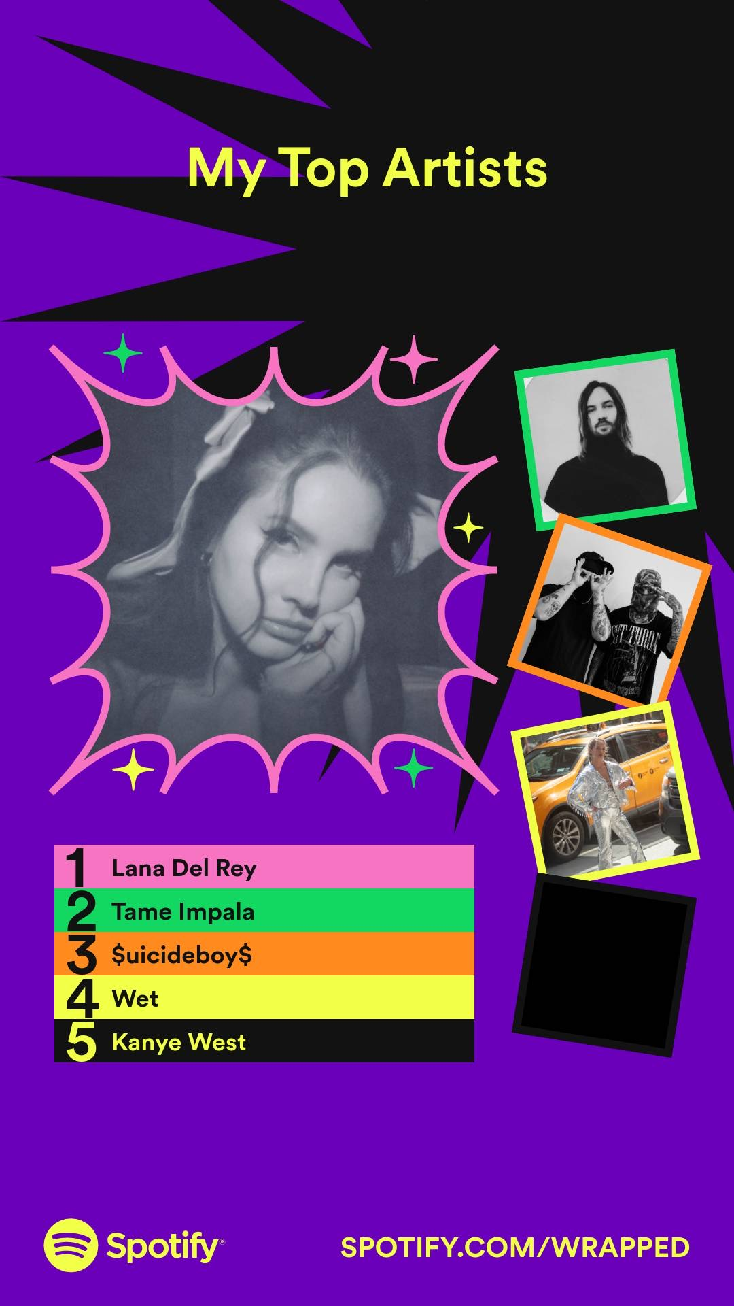

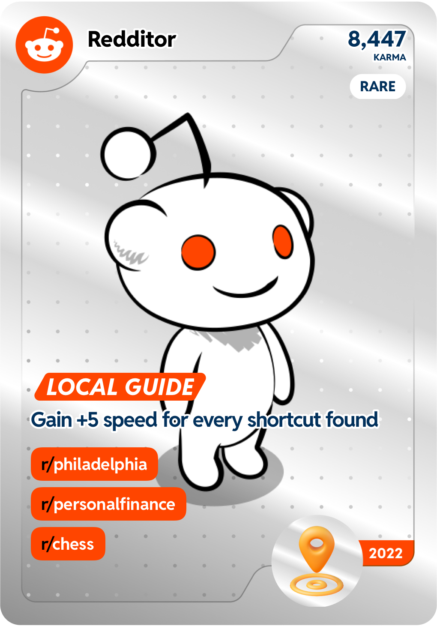

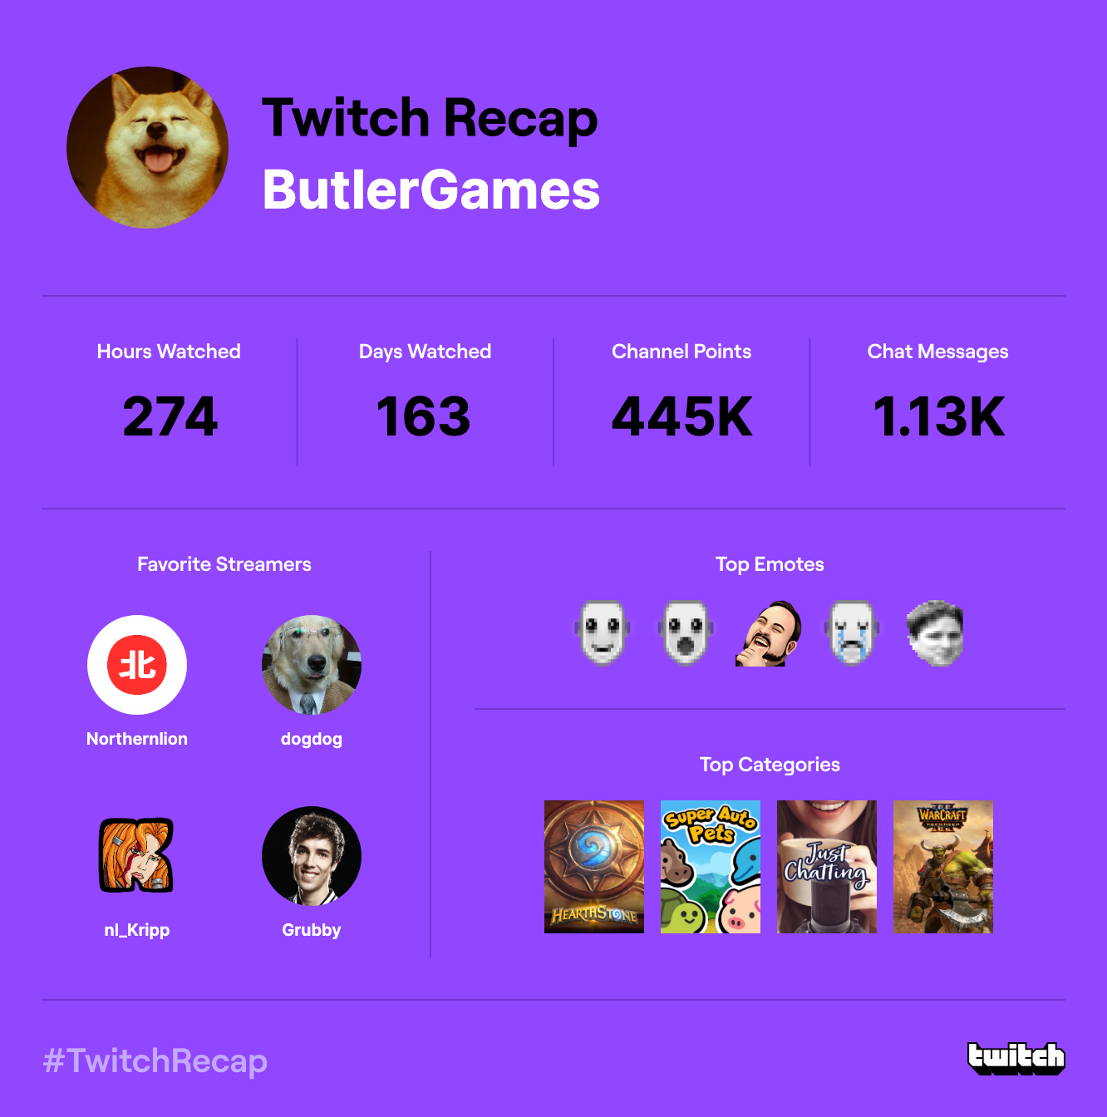

Other updates include passing two tests and taking a college course. I'm hoping to move to another city and perhaps even another one in the upcoming year. Life is increasingly tremendous.

We may do our utmost, but best we end up as no more than beef jerky.

<https://www.youtube.com/watch?v=EEDTDhjXlWk>

Seoul - Stay With Us